AMANA TRUST DIAGNOSTICS
No 15, Tudun Wada C, Nasarawa LGA, Kano State.
Phone; +2348164093504, +2348033390574
Email; amanatrust2022@gmail.com

1/5/2026 11:40:09 AM

NAME: FATIMA SAID | Age :AD | Sex: F | Ref No:00010
Clinical Details: USG Pelvic |  |  | US:10

REAL TIME PELVIC ULTRASONOGRAPHY EXAM: REVEALED:

URINARY BLADDER: Distended with urine with normal mucosal thickness. No gross masses or stone seen.

UTERUS: The uterus is gravid and shows single gestational sac with double decidual sac sign, yolk sac and embryo are not yet seen in the uterine cavity. Right and Left adnexa are free.

GSD= 4 mm.
EGA= 04 weeks 01 days.
EDD= 14/09/2026 ± 2weeks.
CUL-DE-SAC: No sonographic abnormalities detected in anterior and posterior cul-de-sac.

CONCLUSION: Early Cyesis at about 04 weeks 01 days.
Rescan after 3-4 weeks to confirm viability

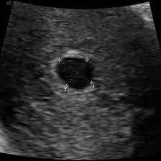
Ultrasound Specialist

